Employee Salary Prediction System

Introduction:
Creating a custom dataset for an Employee Salary Prediction System requires a balance between randomness and realistic logic. For instance, salary should generally correlate positively with experience and education level.
Dataset Overview:
The dataset was synthetically generated to simulate a corporate environment for a Salary Prediction Model. It consists of 200 unique employee records with 10 features, capturing demographic, educational, and performance-related metrics.

Feature Descriptions
- Employee_ID: A unique identifier for each record.
- Age: The age of the employee (Range: 22–60).
- Gender: Categorical variable for demographic diversity.
- Education: Highest degree attained (Bachelors, Masters, or PhD).
- Department: The functional area where the employee works.
- Experience: Number of years of professional experience (Logically capped by Age).
- Working_Hours: Average weekly hours worked.
- Performance_Score: A scale of 1–10 based on annual reviews.
- Projects_Completed: Total number of projects delivered, correlated with years of experience.
- Salary (Target): The annual compensation, calculated using a weighted formula based on experience, education, and performance.

Data Generation Logic & Heuristics
To ensure the model can learn meaningful patterns, the following rules were applied during generation:
- Experience Constraint: Experience was calculated as Age -text (Education Entry Age) to ensure no 22-year-old has 10 years of experience.
- Salary Weighting: Experience was treated as the primary driver of salary.
  - Education provided a "step-up" in base pay (PhD > Masters > Bachelors).
  - Performance Scores added a variable bonus to simulate merit-based pay.
- Stochastic Noise: A Gaussian (normal) distribution of noise was added to the salary to mimic real-world market fluctuations and prevent the model from finding a perfect, non-realistic mathematical linear fit.

Summary Statistics
- Total Records: 200
- Data Format: CSV
- Target Variable: Salary (Numerical/Continuous)
Data Preprocessing:

Data Cleaning
- Missing Value Imputation: Checked for null entries across all features. Numerical columns were handled using the median to prevent outlier influence, while categorical columns were filled using the mode.
- De-duplication: A redundancy check was performed; any duplicate rows (based on all features excluding Employee_ID) were removed to prevent data leakage and model bias.

Feature Engineering & Encoding
To make the data compatible with mathematical algorithms, categorical text was converted into numerical format:
- Ordinal Encoding: Since Education has a logical hierarchy (Bachelors < Masters < PhD), it was mapped to integers (0, 1, 2).
- One-Hot Encoding: For Gender and Department, where no inherent order exists, "dummy variables" were created. One category was dropped ($k-1$ encoding) to avoid the multicollinearity trap.

Feature Scaling
Because features like Age (22–60) and Projects_Completed (1–50) have different magnitudes, Standardization (Z-score scaling) was applied.
This centers the mean at 0 and scales the variance to 1, ensuring that features with larger numerical ranges do not unfairly dominate the model's weight updates.

Data Splitting
The dataset was partitioned into two sets:
- Training Set (80%): Used to teach the model the relationship between employee features and salary.
- Testing Set (20%): Held back as "unseen data" to evaluate the model's accuracy and check for overfitting.
Machine Learning Algorithm:

i)Linear Regression:

To predict the exact salary values, we use Linear Regression. This algorithm assumes a linear relationship between the input features (like Experience and Performance Score) and the target variable (Salary).

Explanation of Evaluation Metrics
- MAE (Mean Absolute Error): The average amount the model is "off" in dollars.
- MSE (Mean Squared Error): The average of the squares of the errors. It penalizes larger errors more heavily.
- R2Score: Indicates how well the features explain the variation in salary. A score of 1.0 is a perfect fit.
ii)Logistic Regression:
To classify employees into High, Medium, and Low salary categories, we use Logistic Regression. Although "Regression" is in the name, it is a classification algorithm that predicts the probability of a data point belonging to a specific category.
For three categories, the model uses the One-vs-Rest (OvR) or Multinomial approach to calculate the likelihood of each class.

Key Concepts in this Step
- Multinomial Logistic Regression: Since we have three classes (High, Medium, Low), the model uses the Softmax function to determine probabilities.
2. Accuracy: This tells you the percentage of employees whose salary category was correctly guessed by the model.
3. Confusion Matrix: This is a table that shows where the model got confused (e.g., how many "High" salary employees were incorrectly predicted as "Medium").
iii)Randam Forest:
To improve the prediction performance, we use the Random Forest algorithm. Unlike Linear Regression, which assumes a straight-line relationship, Random Forest is an ensemble method that combines multiple Decision Trees to capture complex, non-linear patterns in the data.
It is generally much more accurate for datasets where features interact in non-linear ways (e.g., how the combination of "Experience" and "Department" affects "Salary").

Summary of Comparison Metrics
- R2 Score (Regression): Higher is better (1.0 is perfect). If the Random Forest R2is higher than Linear Regression, it means the model is much more precise.
- Accuracy (Classification): Tells you the percentage of correct labels (Low/Medium/High).

Visualization:
To visualize the patterns in your data and the behavior of your models, we use libraries like Seaborn and Matplotlib. This step is crucial for "exploratory data analysis" (EDA) and for interpreting the "black box" of Machine Learning.

Explanation of the Graphs
- Salary Distribution: Shows if your salaries are skewed (e.g., if most people earn a low wage) or normally distributed.
- Correlation Heatmap: Identifies which factors are strongly linked. For example, a high positive number between Experience and Salary (r≈0.9) means as experience goes up, salary almost always goes up.
- Experience vs Salary: A regression plot that shows the "line of best fit." It helps visualize how much each additional year of experience is worth.
- Department-wise Comparison: Uses boxplots to show the median, spread, and outliers of salaries in different departments (IT, Sales, etc.).
- Feature Importance: This is the most powerful visualization for ML. It tells you exactly which variable (like Performance_Score or Education) the Random Forest model relied on most to make its predictions.
Model Evaluation:
To conclude the modeling phase, the performance of different Machine Learning algorithms must be compared. Since the work involves both Regression and Classification, separate evaluation metrics are used for each technique.

Metrics Explained
- MAE (Mean Absolute Error): The average error in dollars. If MAE is 4000, your prediction is typically off by $4,000.
- MSE (Mean Squared Error): Squaring the errors makes large mistakes stand out more. It's useful if you want to strictly avoid big misses.
- R2 Score: A value between 0 and 1. If it's 0.95, it means 95% of the change in salary is explained by your features (Age, Exp, etc.).
- Accuracy: The percentage of people assigned to the correct "High/Medium/Low" bucket.
- Confusion Matrix: A visual tool to see where the classifier failed. For example, it might show if "Medium" earners are often mistaken for "Low" earners.
Front-End Development:
To bring the Employee Salary Prediction System to life, we will use Streamlit, a powerful Python framework for building interactive web apps.

Interface Design
The application is designed using a modular layout to separate user interaction from data analysis.
- Sidebar Navigation: Used for data entry. This keeps the main dashboard clean and allows users to adjust parameters while immediately seeing the effect on the prediction.
- Tabbed Interface: Organized into three logical sections:
  - Predictor: Focused on the core business problem.
  - Exploration: Provides transparency by showing the underlying data.
  - Metrics: Builds trust by showing the statistical validity of the models.

Interactive Components
- User Input Form: Utilizes st.slider for numerical ranges (Age, Experience) and st.selectbox for categorical features (Education, Department). This prevents "garbage in, garbage out" by restricting inputs to valid ranges.
- Real-time Visualization: Integrated Matplotlib and Seaborn to render correlation plots. The scatter plot helps users visualize the linear relationship between experience and salary.

Model Comparison Methodology
The comparison section evaluates multiple algorithms to justify the final model selection:
- Linear Regression: Serves as a baseline model to capture the general trend.
- Random Forest: Utilized to capture non-linear relationships and interactions between features (e.g., how education level might boost the value of experience).
- Evaluation Metrics:
  - Mean Absolute Error (MAE): Represents the average dollar amount the prediction is off by.
  - R-Squared ($R^2$): Measures how much of the salary variance is explained by the model.

Tech Stack
- Streamlit: For UI components and web hosting.
- Pandas: For data manipulation and table rendering.
- Matplotlib/Seaborn: For statistical data visualization.
- Scikit-Learn: For the backend predictive logic and metric calculation.

Screenshot1:
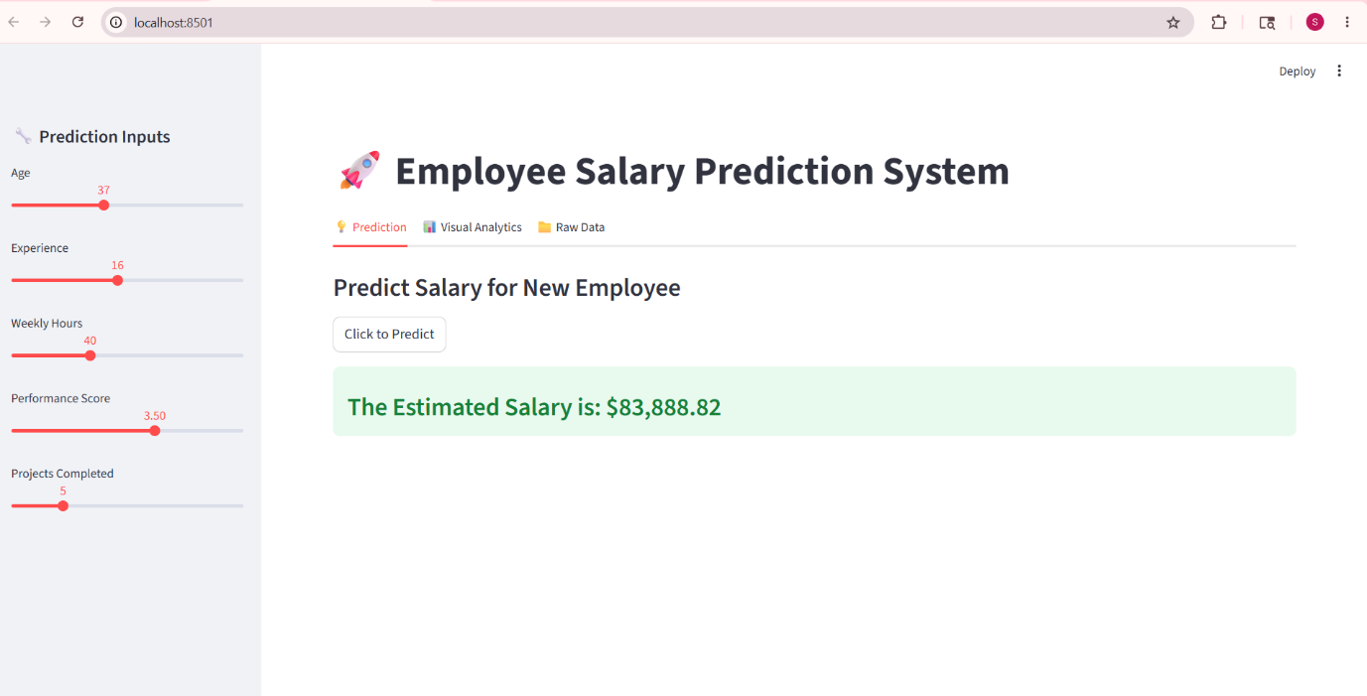
Screenshot2:

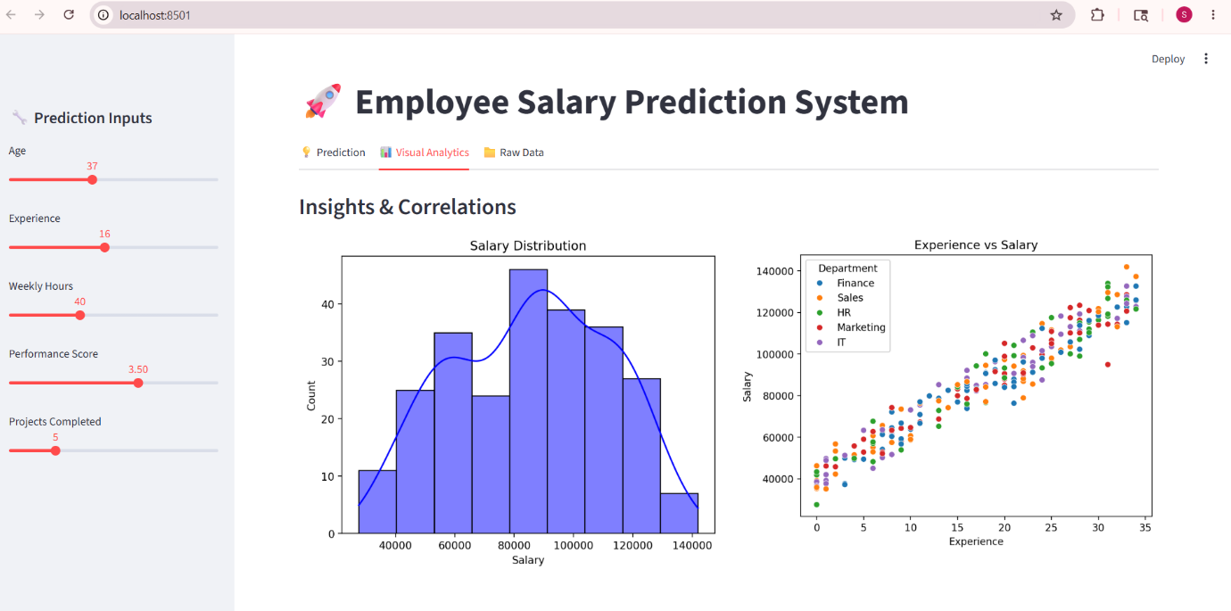

Screenshot3:

